ASR 5453 request reprint single ship mark

Date 30 June 2015

Add button [Print Single] - to allow reprint single ship mark.

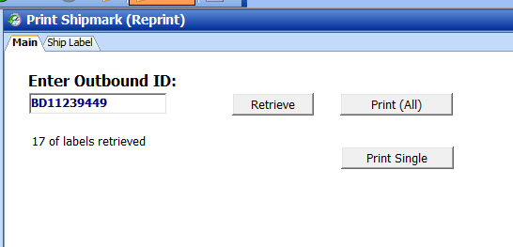

* Click to print single ship-mark label for the Outbound ID #

Print single:

